# Highest Level, 1: Based on warehouses

## With the sum of sales for each warehouse over all the time of the data, it can be seen that:

* Generally, the sum of sales for Prague_1 and Brno_1 outperformed the other warehouses for most of the time (The chart below viewed from year level). While German warehouses do not seem to bring much revenue for Rohlik because their sales are the least with Frankfurt_1 hardly ever reached 5m during the time.
* The sales from warehouses located in Czech Republic also accounted for the most of Rohlik sales, which could possibly explained as there are 4 different warehouses out of 7 of Rohlik are placed here. Hungary, even though with only Budapest_1 warehouse still have larger sales then 2 warehouses of Germany namely Munich_1 and Frankfurt_1

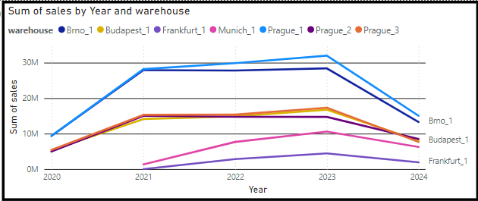

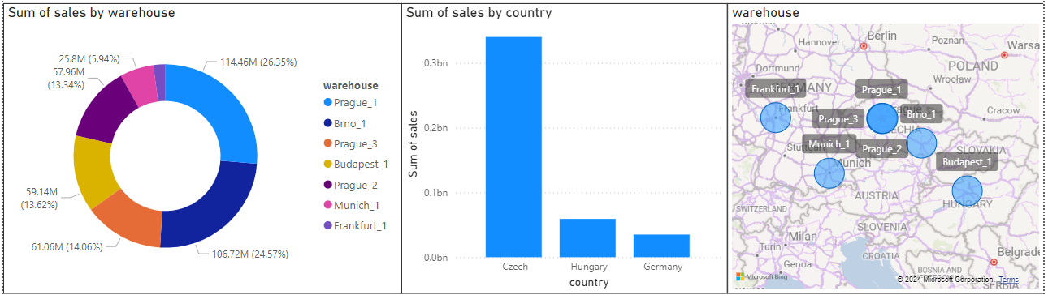

* Both warehouse Prague_1 and Brno_1 have the same sales sum variation as the shape of the line displays. The magnitude of values are also slightly the same, when both of them are the 2 with highest value.
  + This trend is not hard to be found whether we view it in year, quarter, month or day level.
  + From the year level, sales of these 2 warehouses both went up significantly from 2020 to 2021 from slightly 10m to around 29m, since then until 2023 their increases was not so dramatic anymore but Prague_1 had a better up surge and got over 30m for sum sales. From 2023 to around middle of 2024, their sum of sales suddenly deep dived, Brno_1 landed at around 13m and Prague_1 was around 12m

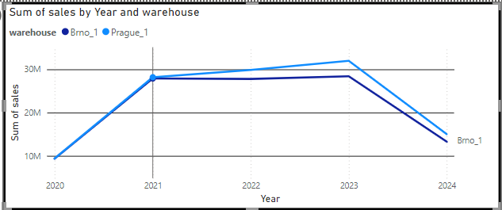

* + As we go more detail in level, for example with month, one easily spotted patterns could be observed is that the sales for these 2 keep going up and down in 2 phases: started increasing from around july or august from the previous year and until the first quarter of the next year (around february or march). Since then the sales would go down until july or august and the cycle repeats. So far in 2024, there has been an increase from august 2023 to may 2024 and **could be predicted to keep cumulated until july or august of 2024. Note: The sum of sales for june 2024 suddenly dropped down as the data only record the first 2 days of the month.**

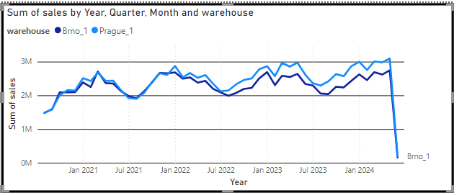

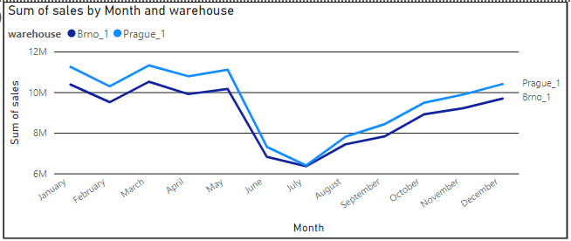

* Sales for warehouses Prague_2 and Prague3 also followed the same variation. While Prague_3’s sales has almost the same cycle, Prague_2 witnessed a drop down in February of 2023 and fluctuated around 1m until july of the year. From this view, as we see changes in month across all the year, Munich_1, Frankfurt_1 and Budapest_1 sales did not ensemble the other 4 from Czech. While the only warehouse from Hungary had sales fluctuated with no noticeable changes, Munich_1 showed gradual increase in sales from june 2021 to may 2024, especially January of every seemed like a spring, as after the month the sales usually reach its local maxima, slightlly flatted out for half year and then kept going up until January of the next year. The sales for Frankfurt_1 was pretty low but witnessed a stable growth from around September 2022 to June 2024.

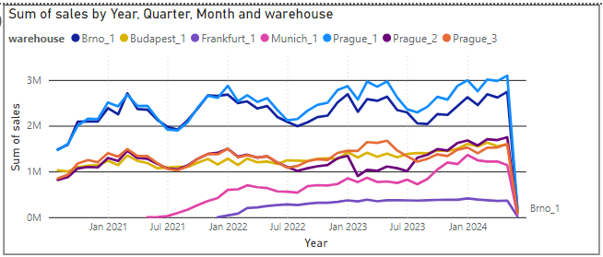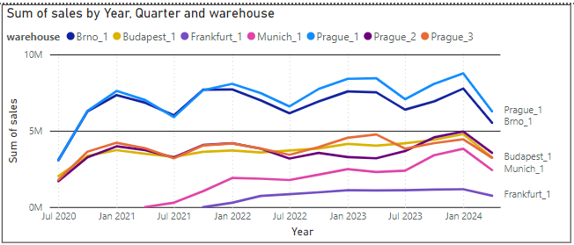

* This is the sales when viewed according to month of the data time range. There is usually a remarkable decrease around mid may that last until mid july or august and started to recover (corresponding to third quarter of the year). It looks like all warehouses follow this pattern but with different changing magnitude.

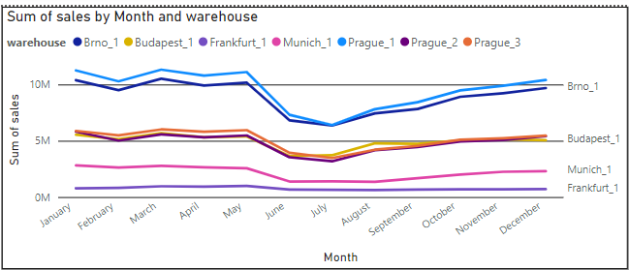

* In terms of sales of each day of the month, usually the last 4 days of the month that sales for all warehouses started to decrease quite significantly, while the other days seemly witnessed ups and downs with not so large deviation

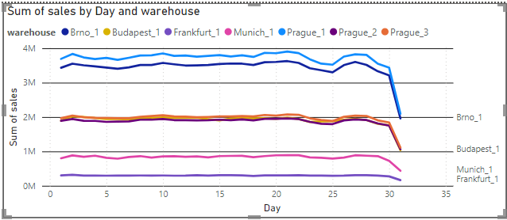

* The mid-year cycle could be explained as follow for warehouses in Czech and Hungary:
  + This happened for all categories at the lowest level.
  + The sum of sales drop around July and August of every year, at which it started to rise again until December or January of the next year and the cycle repeated
  + That fall in third quarter of the year may be due to the summer break when people not tend to buy to much groceries for saving for the next months but only buy as needed, the warm weather did not force them to save food in-house.
  + The re-rise after August could be explained as people or retailers getting ready for the upcoming Christmas, they bought more goods for using and selling. The peak at Dec or Jan of next year might be because after 2 weeks of Christmas, people need more stuff and retailors knew that people would buy more, so more sales appeared. Moreover, people sometimes bought more in January for getting ready for the winter break. There are also other important holiday in Summer and Fall.
  + Date 27 to the last of the month usually not so effective in sales as they went down pretty much. This rule could be seen in all warehouses.
  + The holiday did not affect the sales of Frankfurt_1 warehouse so much

**==> Market in Germany may not be the one with most sales, however its stable growth indicates a good sign for being potentially important market. Hungary with warehouse in Budapest is somewhat a good but not so remarkable market in terms of sales, while Czech Republic crowns the market of Rohlik.**

**==> We have investigated the sales in sum level for each warehouse and ambiguously predict the general trend, let’s if the more detail level would follow the same as each of those product variants could contribute to this pattern of the sales.**

**For Brno_1, Prague_1-3**

* **The mid-year cycle**
* **The last 4 days of the year**

# Level 2: Based on category

### Sum of sales by time of each warehouses with respect to the least detail category:

* With respect to the category, here we refer to the least detail category, which is the name such as meat and fish, bakery, fruit and vegetable, in all of the warehouse the sum of sales for each type of product showed similar characteristic: Bakery and “Fruit and Vegetable” have always been the most to be sold in these warehouses, and F&V always has the highest value whilst meat and fish is at the bottom of the table.
  + Rohlik business could mainly be centralized around non-animal products as the sales displayed, they must have known this. These diary and green products have brought them lots of sales during the time.
  + These 2 main categories could have the most impact on overall Sales, so we may dive deeper into them.

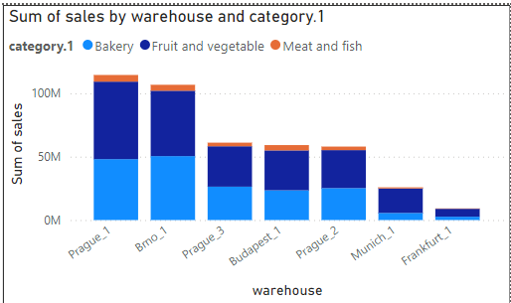

* As we have predicted, the sales trend of each of these categories should form the sales in general, that is why the sales variation pattern for each kind of product possessed a similar changes.

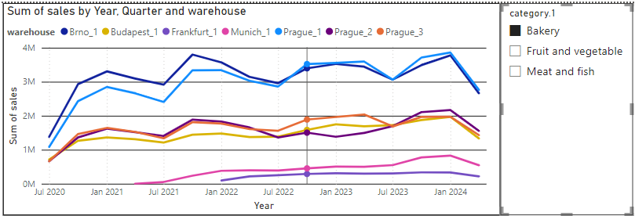

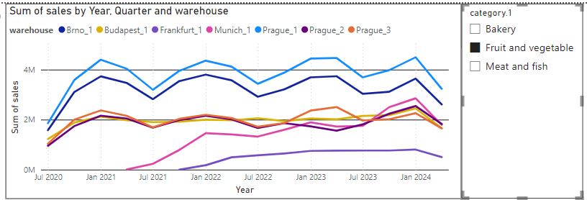

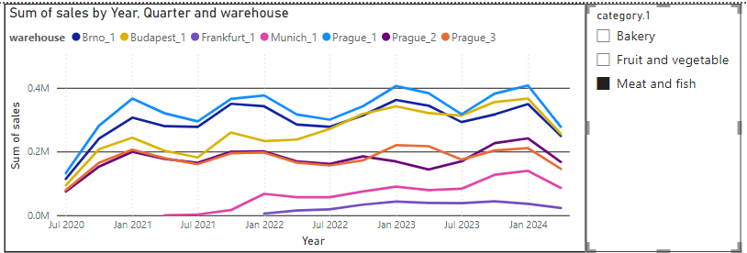

**==> So our assumption would be that those more detail category level would also follow this pattern, as well as the product's sale. Let’s check them out.**

### We gonna examine what are the products that occupied most of the sales of warehouses by category, because they could be the main reason why sales for those warehouses having the same pattern:

#### Brno_1, Prague_1, Prague_2, Prague_3 warehouses

* These are products with most sales for each category:
  + Bakery: Roll, Bread, Pastry, Baguette, Toust, Donut, Croissant, Snack, Tortilla, Pretzel. Those that occupy more than 0.8% in the Pie chart. They follow both rules found for the level 1.

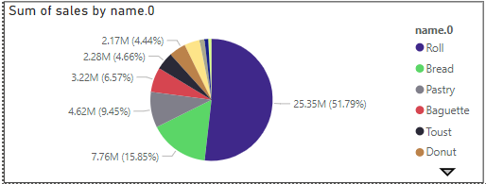

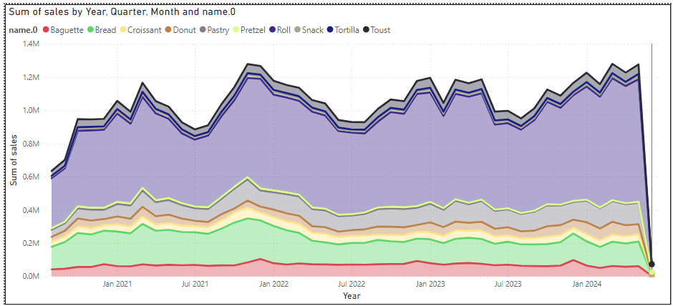

* Among the rest of products: Bun, Cake, Muffin, Breadcrumb, Cracker, Waffle, Breadcrumbs, Cheese, Rice Cake and Pita seem to have something in similar in terms of sale. There looks like a new trend here for these products: **They were tended to be bought more in quarter 4 of the year or specifically December. Sales usually started from November of the year. These might be those foods that suit winter or Christmas.**

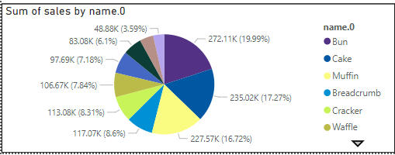

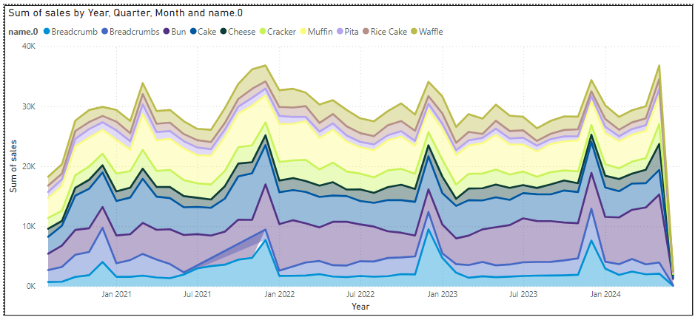

* How about the minor set of the product: Biscuit, Brioche, Cone, Focaccia, Pasta. With the exception of Biscuit whose sales was quite slowly stable, the other 4 kind of varied in the same way but not showing certain pattern.

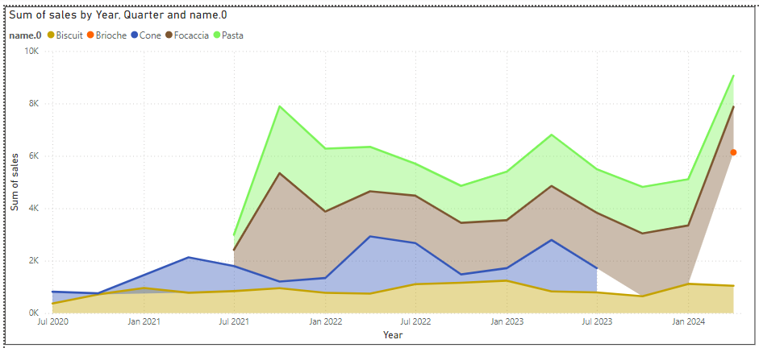

* Fruit and Vegetable: Cucumber, Banana, Tomato, Potato, Carrot, Apple, Onion, Avocado, Lettuce, Grape, Radish, Watermelon, Kiwi, Lemon, … Pear. Those common products dominated the overall sales for this category. Most of them follow the **mid-year rule**

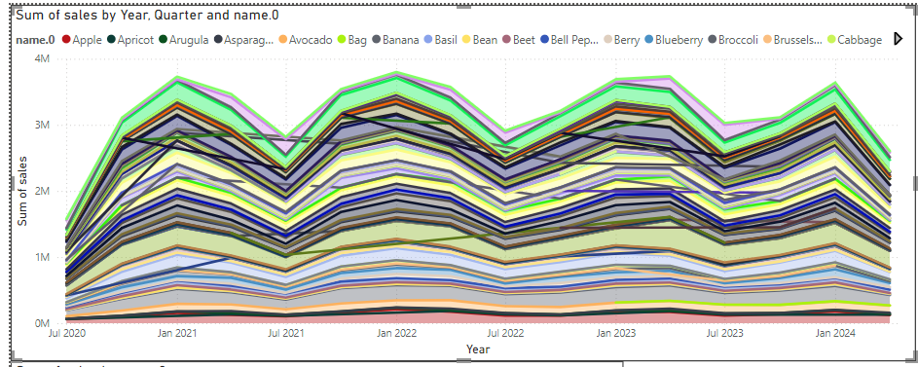

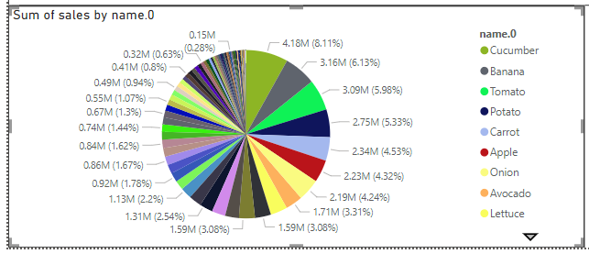

* There are several fruits or vegetables that are seasonal, so their sale could focus only on certain months of the year: Litchi in Spring, Melon or Cherry in Summer,...

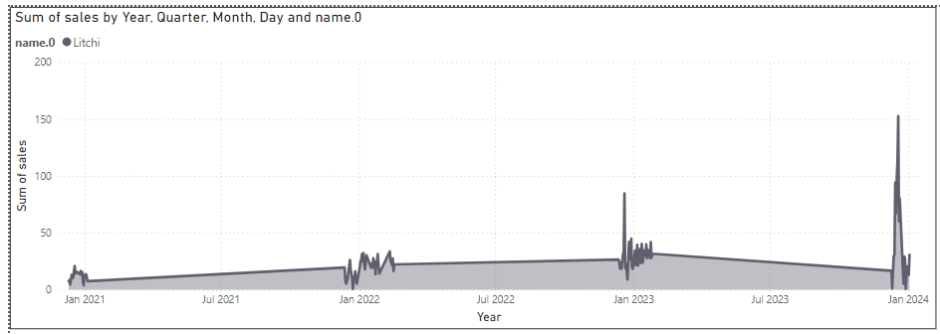

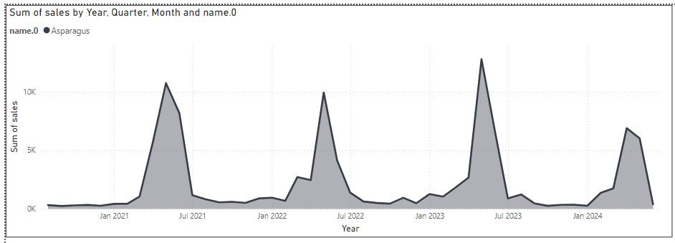

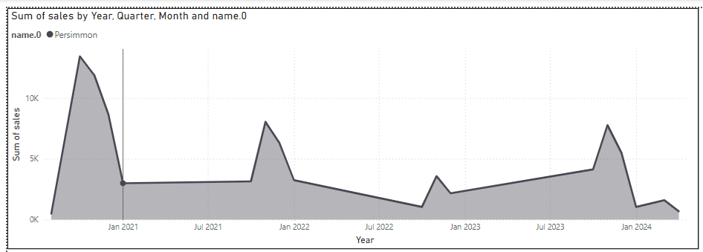

* There could be other variants of trend but the main and most significant one is still the mid-year cycle rule.
* Meat and fish: Common Products like Beef, Chicken, Pork, Salmon and Turkey sales follow the mid-year cycle rule.

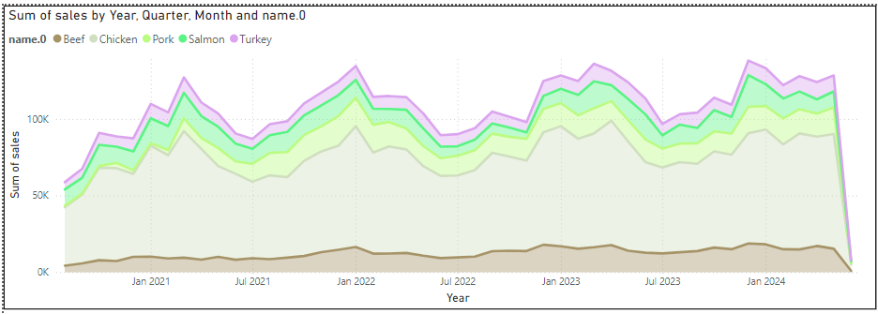

* Shrimp and Mix Meat, both sales tended to going around February and March for every year.

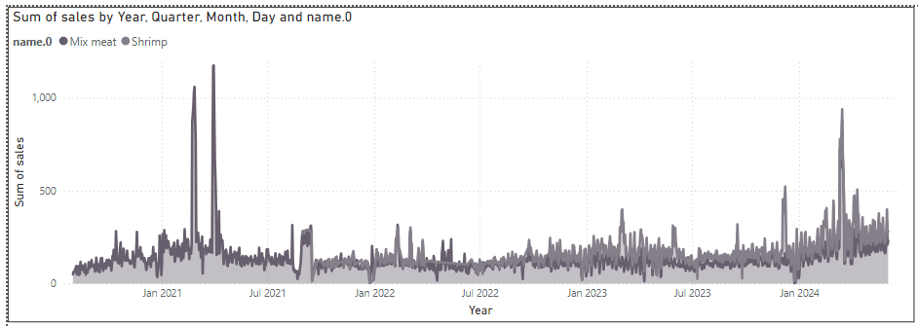

* Duck were consumed more in November, especially first 3 weeks of November of all year, while Carb, indicates that people around the region were more likely to buy this in December, this appeared as a new trend since 2022 to 2023, and could possibly continue to 2024.

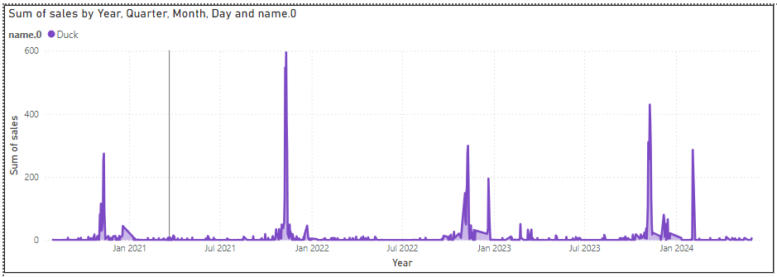

#### Frankfurt_1 warehouse

* These are products with most sales for each category:
  + Bakery: Bread, Pastry, Pretzel, Roll, Croissant, Toust, Sandwich, Baguette, Bagel, Donut. Those that occupy more than 0.8% in the Pie chart. They follow both rules found for the level 1.

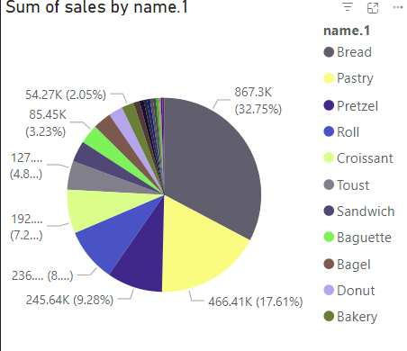

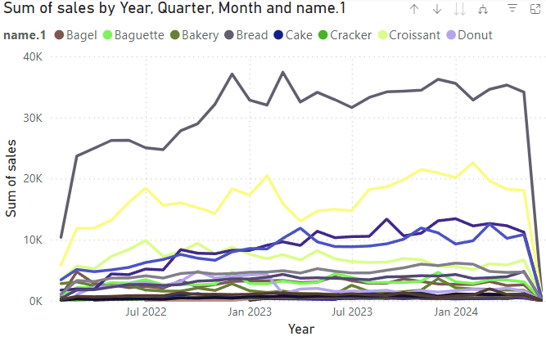

* Other products: Bread, Pastries, Pretzels, Rolls, Croissants, Tousts, Sandwiches, Baguettes, Bagels and Donuts saw a significant increase in sales in the fourth quarter of the year, especially from November to December. This could be because these products are suitable for the winter or Christmas season, when consumer demand increases.

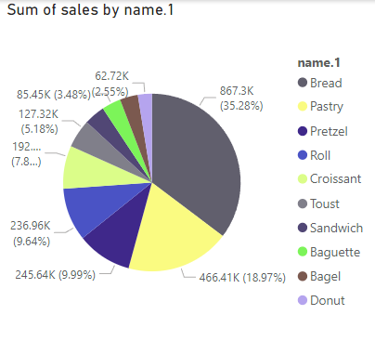

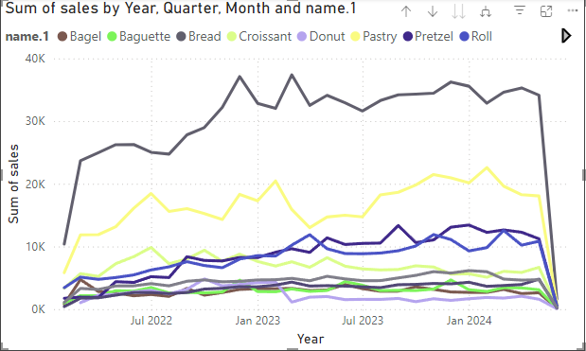

* Products like Pita, Rice Cake, Breadcrumbs, Crackers and Cheese tend to see a slight increase in sales in the fourth quarter of the year, especially from November to December. This could be because these products are suited for winter or festive seasons, when consumer demand is high. But overall sales are the lowest among the products

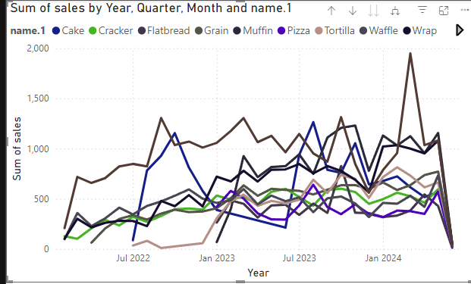

* Fruit and Vegetable: Cucumber, Tomato, Apple, Avocado, Banana, Potato, Kiwi, Blueberry, Onion, letturce, carrot, … Pear. Those common products dominated the overall sales for this category. Most of them follow the **mid-year rule**
* Most fruit and vegetable products tend to have seasonal sales. Products such as cucumbers, tomatoes, apples and kiwis have high sales in the middle and late year, **corresponding to their autumn and consumption seasons**. Bananas and onions have stable sales **year-round**, not much affected by season.

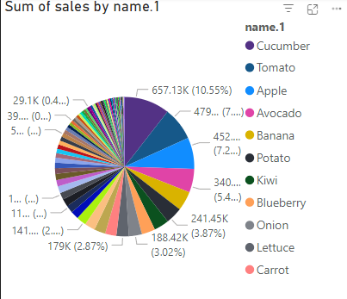

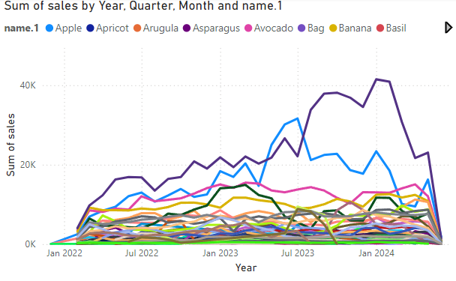

* The analysis shows that the lowest-selling products such as Pears, Cabbage, Chestnuts, Peppers, Juice, Chicory, Rutabaga, Kohlrabi, Fennel, and Okra do not have a clear seasonal sales trend. Sales of these products are generally stable and not much affected by the season of the year, except for Chestnuts which tend to increase slightly in winter.
* Products with the lowest sales are often unpopular, not a key ingredient in many dishes, or have a taste and texture that is not favored by the majority of consumers. This results in them having lower sales than other products.

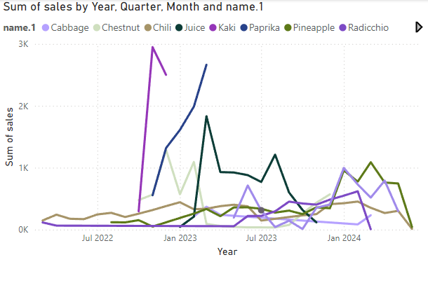

* There could be other variants of trend but the main and most significant one is still the mid-year cycle rule.
* Meat and Fish:

Beef is the largest revenue product, accounting for 44.84% of total revenue.

Salmon is second at 31.37%.

Chicken accounts for 12.73%.

Other products such as Burgers, Plant-based Meat, Mixed Meat, Shrimp, and Turkey have relatively low revenue percentages, ranging from 2% to 3.6%.

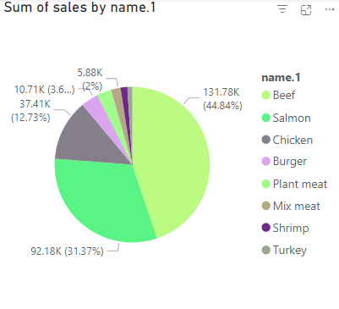

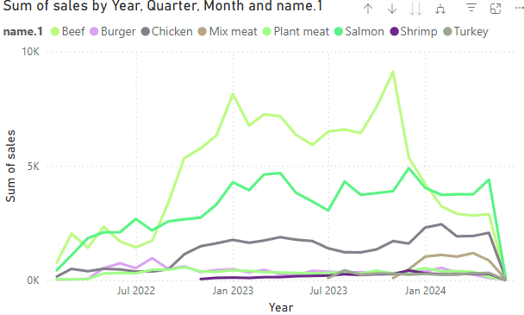

Plant-based meat and chicken have high and stable sales, indicating high consumption trends.

Beef, burgers, mixed meats, salmon, shrimp, and turkey have lower sales, but remain stable with some slight fluctuations.

(Plant Meat)

Trend: The curve starts to increase sharply from mid-2023, peaking at the end of the year.

Cause: New products or a growing trend of vegetarianism, leading to a late launch but gaining popularity quickly.

(Burger)

Trend: The curve starts in early 2023 and increases gradually until the end of the year.

Cause: This could be due to marketing strategies or advertising campaigns that are launched later than other products.

(Shrimp)

Trend: The curve starts to increase significantly from mid-2023.

Cause: Changes in consumer preferences or shrimp fishing season lead to late sales growth.

(Turkey)

Trend: The curve starts in early 2023 but only really increases sharply towards the end of the year.

Reason: Often consumed heavily during year-end holidays like Thanksgiving, leading to a late increase in sales.

#### Munich_1 warehouse

* Bakery:

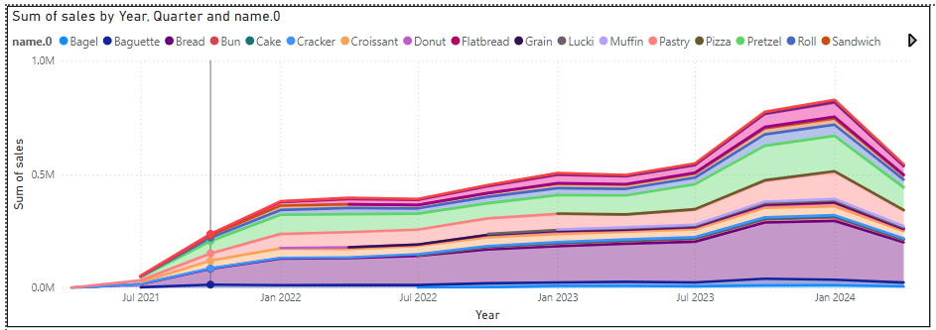

**Strong Growth in Spring and Summer**: Sales tend to surge significantly from Q2 (April - June) and peak in Q3 (July - September). This could be due to increased demand during the tourism season and outdoor events, where bakery products are often favored.

**Slight Decline in Fall and Winter**: After peaking in Q3, sales typically see a slight decline in Q4 (October - December) and Q1 of the following year (January - March). Colder weather and fewer outdoor events are likely the main reasons for this trend.

* Fruit and Vegetable, the trend is somewhat like bakery

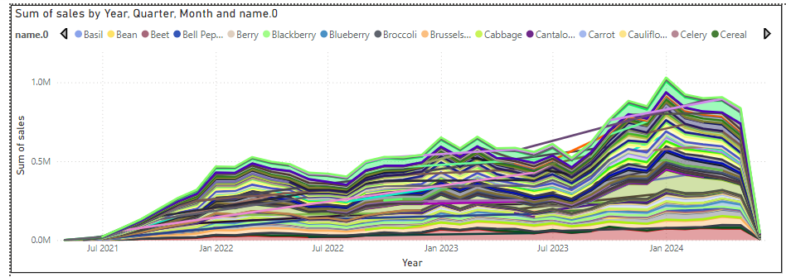

* Meat and Fish

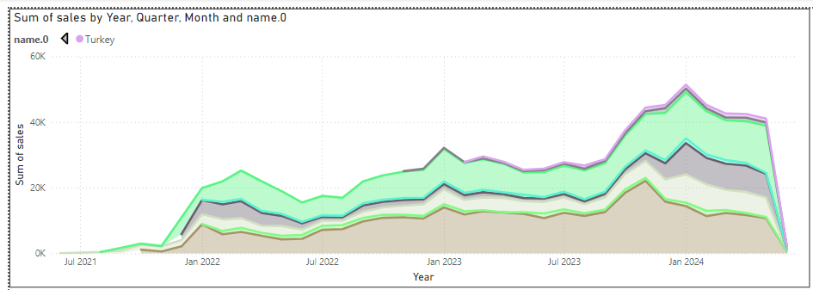

⇒ From third quarter of 2023, there could have been some improvements in marketing strategy or technologies that make the sales for al products went up quite much from this phase

⇒ The sales for Munich_1 in general and specifically each product witnessed an stable growth, which could continue for the next following years.

### Key Factors Influencing Sales Trends:

* **Tourism Season**: Munich is a popular tourist destination, especially in spring and summer when the weather is pleasant and there are numerous festivals and events.
* **Consumer Habits**: Locals and tourists alike tend to consume more bakery products during festive seasons and while participating in outdoor activities.
* **Special Events**: Festivals such as Oktoberfest, Christmas markets, and summer events can create sudden spikes in demand for bakery products.

#### Budapest_1 warehouse

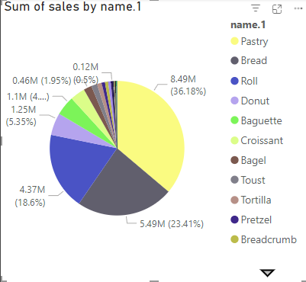

Top-Selling Products

1. **Pastry**: 36.18% of total sales
2. **Bread**: 23.41% of total sales
3. **Roll**: 18.6% of total sales

**Cultural Preference**: Pastries, bread, and rolls are staple foods in Hungarian cuisine, leading to higher demand.

**Quality and Variety**: Bakeries in Budapest, such as Arán and Artizán, are known for their high-quality ingredients and diverse offerings2.

**Tourism**: Budapest attracts many tourists who enjoy trying local baked goods, boosting sales.

**Convenience**: Bakeries often offer convenient grab-and-go options, appealing to busy locals and tourists alike.

##### Other Products

* **Donut**: 5.35% of total sales
* **Baguette**: 4.69% of total sales
* **Croissant**: 1.95% of total sales
* **Bagel, Toust, Tortilla, Pretzel, Breadcrumb**: Each around 0.5% of total sales

**Cultural Preferences**

Local Cuisine: Bagels, toast, tortillas, pretzels, and breadcrumbs might not be as deeply rooted in Hungarian culinary traditions, leading to lower local demand.

Product Familiarity: Consumers tend to prefer products they grew up with or are more familiar with, which might not include these specific items in large quantities.

**Market Factors**

Limited Usage: Some of these items, like tortillas and breadcrumbs, may have more specific uses and are not as versatile as bread or pastries, which can be eaten on their own or with a variety of spreads and fillings.

Availability: These products might be less readily available or not as prominently displayed in local bakeries, leading to fewer sales.

**Tourist Influence**

Tourist Preferences: Tourists might lean towards trying more traditional or unique local products rather than items they can find easily at home.

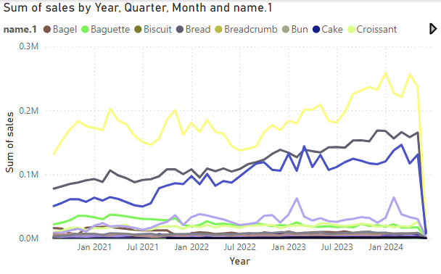

##### Monthly Sales Trends

1. **January to March**:
   * **Moderate Sales**: Post-holiday slowdown, but still steady demand for everyday items like bread and pastries.
2. **April to June**:
   * **Increased Sales**: Spring holidays and warmer weather boost sales of light, fresh baked goods like croissants and rolls.
3. **July to September**:
   * **Peak Sales**: Summer holidays and tourism season lead to high demand for all bakery items, especially pastries and cakes.
4. **October to December**:
   * **High Sales**: Autumn festivals and the run-up to Christmas see increased sales of festive items like cakes and specialty breads.

##### Reasons for Seasonal Variations

1. **Holidays and Festivals**: Sales peak during major holidays such as Easter, summer vacations, and Christmas due to increased consumer spending and gatherings.
2. **Tourism**: Summer months attract more tourists, leading to higher sales as visitors indulge in local bakery products.
3. **Seasonal Preferences**: Warmer months may see a preference for lighter baked goods, while colder months boost sales of richer, more indulgent items.

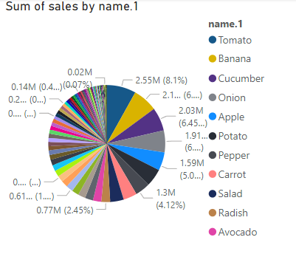

There are a lot of items overall so I analyzed the top 10 highest and top 10 lowest and focused on the trend.

- Top10

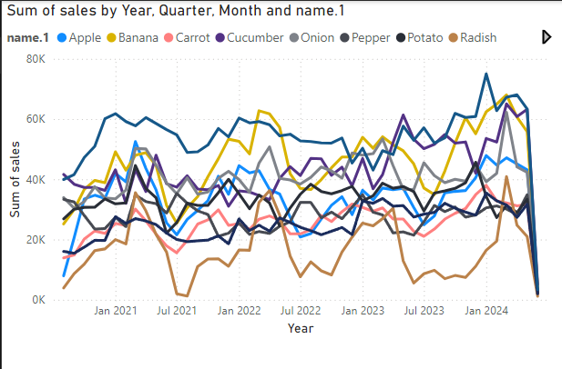

1. **Tomato**
   * **Peaks**: Spring and early summer (March to June) and late summer (August).
   * **Reason**: High demand during salad season and peak growing seasons.
2. **Banana**
   * **Stable Sales**: Year-round.
   * **Reason**: A staple fruit with consistent demand.
3. **Cucumber**
   * **Peaks**: Summer months (June to August).
   * **Reason**: Popular in salads and cold dishes during warmer weather.
4. **Onion**
   * **Stable Sales**: Year-round with slight increases in winter.
   * **Reason**: Essential in cooking, with higher usage in winter dishes.
5. **Apple**
   * **Peaks**: Autumn (September to November).
   * **Reason**: Harvest season and increased consumption in cooler months.
6. **Potato**
   * **Stable Sales**: Year-round.
   * **Reason**: Versatile ingredient used in a variety of dishes.
7. **Pepper**
   * **Peaks**: Late summer to early autumn (August to October).
   * **Reason**: Peak growing season and higher usage in fresh dishes.
8. **Carrot**
   * **Stable Sales**: Year-round.
   * **Reason**: Common ingredient in a variety of recipes.
9. **Salad**
   * **Peaks**: Spring and summer (April to July).
   * **Reason**: Higher consumption of fresh greens in warmer months.
10. **Radish**

* **Peaks**: Spring and early summer (April to June).
* **Reason**: Fresh and crisp, popular in spring dishes.

### Seasonal Influences

* **Spring/Summer**: Increased sales of fresh and light produce like tomatoes, cucumbers, and salads.
* **Autumn/Winter**: Higher sales of hearty and versatile items like apples, onions, and potatoes.

There are several reasons why these fruits and vegetables are top-sellers in Budapest:

**High Demand and Usage**

Tomatoes, Cucumbers, and Onions are widely used in many dishes, ranging from salads to stews. Their versatility makes them a staple in many households.

Bananas and Apples are popular due to their convenience as snacks, nutritional value, and their role in various recipes, including desserts and smoothies.

**Cultural Factors**

Culinary Traditions: These items are integral to Hungarian cuisine. For example, onions are a key ingredient in many traditional dishes like goulash.

Dietary Preferences: There is a trend towards healthier eating, and fruits and vegetables are central to a balanced diet.

**Market Dynamics**

Availability: These products are generally easy to source and often available year-round, making them reliable choices for consumers.

Affordability: Many of these items are cost-effective, providing good nutritional value for their price.

**Seasonal Influence**

Local Production: Items like tomatoes and cucumbers are often locally grown, ensuring fresher produce and supporting local agriculture.

Bottom 10

**Sales Trends Analysis**

**Blackberry**

Peaks: Mid-2021 and early 2023.

Reason: Seasonal availability and occasional promotions.

**Cactus**

Peaks: Late 2021 and mid-2022.

Reason: Unique product with niche market appeal.

**Chrysanthemum**

Peaks: Late 2022.

Reason: Popular during specific holidays and events.

**Decorative**

Peaks: Early 2022.

Reason: Used for special occasions and events.

**Juice**

Peaks: Mid-2021 and late 2022.

Reason: Health trends and promotional campaigns.

**Lamb's Lettuce**

Peaks: Early 2021 and late 2023.

Reason: Seasonal availability and health-conscious consumers.

**Parsnip**

Peaks: Mid-2021 and early 2023.

Reason: Seasonal availability and occasional promotions.

**Pea**

Peaks: Early 2021 and mid-2022.

Reason: Seasonal availability and traditional dishes.

**Reasons for Low Sales**

**Seasonal Availability**: Many of these items are not available year-round, leading to periods of no sales.

**Niche Market**: Some products like cactus and decorative items cater to a smaller, more specific audience.

**Lack of Promotion**: Limited marketing efforts for these items compared to more popular products.

**Consumer Preferences**: These items may not be as widely preferred or integrated into daily diets.

Meat and Fish:

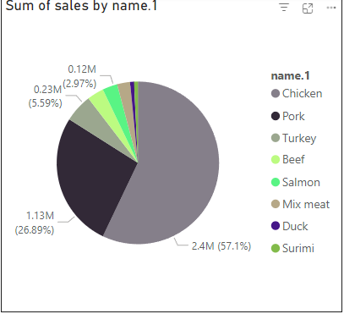

**Chicken**: 57.1%

* **Dominant Product**: Chicken is the most popular meat, likely due to its versatility, affordability, and health benefits.

**Pork**: 26.9%

* **Strong Presence**: Pork remains a staple in many diets, with traditional dishes and recipes driving consistent demand.

**Turkey**: 5.6%

* **Seasonal Demand**: Turkey sees higher sales around holidays like Thanksgiving and Christmas.

**Beef**: 2.97%

* **Specialty Product**: Beef is often considered a premium product, leading to lower overall sales compared to chicken and pork.

**Salmon**: 2.97%

* **Health Trend**: Salmon is popular among health-conscious consumers due to its high omega-3 content.
* **Expensive**

**Mix Meat**: 2.97%

* **Variety Appeal**: Products that combine different meats cater to consumers looking for variety and convenience.

**Duck**: 2.97%

* **Niche Product**: Duck is less common but still popular in certain culinary circles.

**Surimi**: 2.97%

* **Processed Product**: Surimi, a processed seafood product, has a niche market with specific uses in dishes.

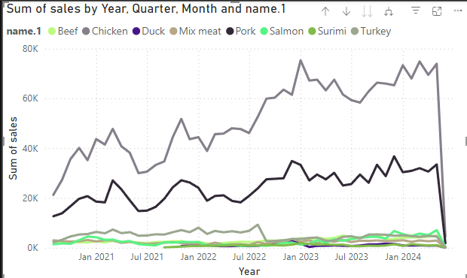

#### Winter (December to February)

1. **Beef**: Higher sales due to its popularity in hearty winter dishes and festive meals.
2. **Turkey**: Peaks in December around Christmas, with significant sales during this festive season.
3. **Pork**: Steady sales as it is a staple in many winter recipes.
4. **Chicken**: Consistent demand, with a slight increase during holidays.
5. **Salmon**: Moderate demand, often used in holiday meals for a healthier option.
6. **Duck**: Higher sales during festive seasons, especially around Christmas and New Year’s.

#### Spring (March to May)

1. **Chicken**: Stable and consistent demand as a versatile ingredient in lighter spring meals.
2. **Lamb**: Peaks around Easter due to traditional recipes.
3. **Salmon**: Increased demand as consumers seek healthier and lighter options.
4. **Mix Meat**: Steady sales, catering to diverse culinary uses.

#### Summer (June to August)

1. **Chicken**: High demand due to its use in barbecues and light summer dishes.
2. **Salmon**: Increased sales as a healthy and refreshing meal option.
3. **Pork**: Consistent sales, often used in summer grilling and barbecues.
4. **Surimi**: Moderate sales as it is popular in salads and cold dishes.
5. **Duck**: Lower demand, as heavier meats are less popular in the heat.

#### Autumn (September to November)

1. **Beef**: Sales start to increase as consumers turn to heartier meals.
2. **Pork**: Steady sales, with some increase due to autumn festivals.
3. **Turkey**: Sales start to pick up in preparation for Thanksgiving.
4. **Chicken**: Consistent demand, remaining a staple in various meals.
5. **Salmon**: Moderate demand as a healthy option.

Summary:

Winter: High sales for festive meats like beef, turkey, and duck.

Spring: Increased demand for lighter meats and fish like chicken and salmon.

Summer: Peak demand for versatile and refreshing options like chicken, salmon, and surimi.

Autumn: Gradual increase in sales of heartier meats like beef and pork, with turkey sales picking up towards the end of the season.

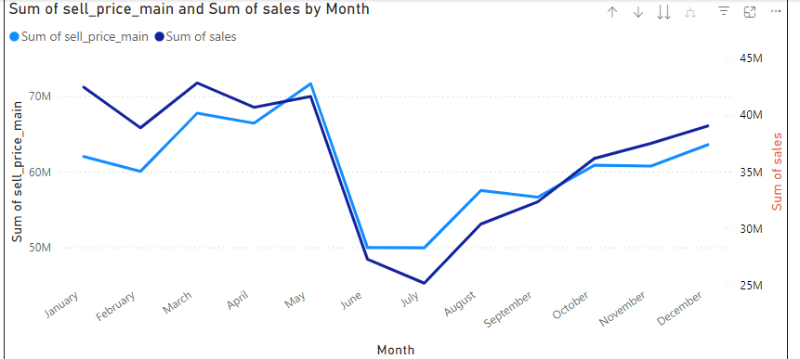

"Sum of sell_price_main"

January: Starts at around 60 million.

February: Peaks at around 75 million.

July: Lows at around 50 million.

December: Ends at around 65 million.

"Sum of sales"

January: Starts at around 35 million.

February: Peaks at around 40 million.

July: Lows at around 25 million.

December: Ends at around 40 million.

Trend Analysis

Seasonal Fluctuations:

January - February: Both selling prices and sales peak. This may be due to the year-end and New Year holidays, when consumer demand increases.

June - July: Lowest level of the year, which may be due to summer when consumer demand decreases, or people travel more.

Year-End Recovery:

From July to December, both prices and sales increased again. This may be related to the preparation for the year-end festive seasons such as Christmas and New Year, when consumer demand increases.

Remarks

Price and Sales Correlation: These two trend lines have a certain correlation, indicating that when prices increase, sales also tend to increase and vice versa. This may be due to higher market demand causing prices to increase, or effective advertising and promotion strategies.

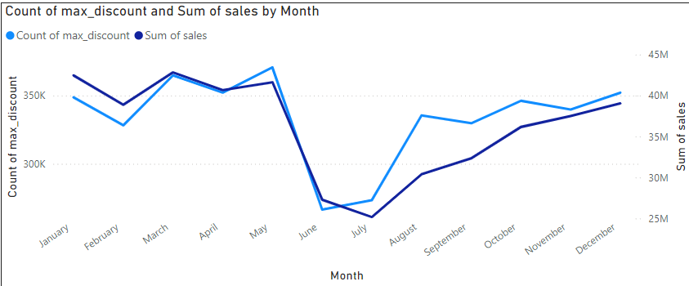

**"Count of max_discount"**

January: Starts at around 350K.

February to May: Slight fluctuations.

June and July: Significant decline.

August to December: Increases again.

**"Sum of sales"**

January: Starts at around 40M.

February to April: Slight decline.

May to July: Significant decline, down to around 25M.

August to December: Increases gradually, reaching around 40M in December.

**Trend Analysis**

Relationship Between Discounts and Sales:

Correlation: The trend lines of "Count of max_discount" and "Sum of sales" tend to correlate with each other. When the number of discounts peaks in February and December, sales also increase. This suggests that heavy discounts can boost sales.

**Seasonal Variations:**

Winter (January and December): Both discounts and sales peak at the beginning and end of the year, possibly due to large promotions around holidays such as Chinese New Year and Christmas.

Summer (June and July): Significant declines, possibly due to lower consumer demand during the summer when people travel.

**Year-End Recovery:**

From August to December, both discounts and sales rebound, possibly related to year-end promotions and increased demand in preparation for the holiday season.

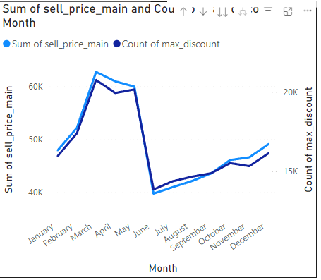

**Chart 1: "Sum of sell_price_main" and "Sum of sales"**

Key Observations:

February and December are high sales months, related to the holidays.

June and July have low sales, possibly due to the summer when people travel more.

**Chart 2: "Count of max_discount" and "Sum of sales"**

Key Observations:

December and January have high discounts and sales also peak during these months.

June and July have low discounts and sales also drop significantly.

**Chart 3: "Sum of max_discount by Month"**

**Key Observations:**

June: Sharp decrease in total maximum discounts.

December: Sharp increase in total maximum discounts, peaking.

Comprehensive Analysis

Relationship Between Discounts and Sales:

Months with high discounting (January and December) are also months with high sales. This indicates that big discounts can boost sales.

**Seasonal Variations:**

Winter (December - February): Increased discounts and high sales due to holidays and festive seasons.

Summer (June - July): Low discounts and low sales due to people traveling and shopping less.

**End of Year Recovery:**

From August to December, both discounts and sales rebound, possibly related to year-end promotions and increased demand for shopping in preparation for the holiday season.